EXPERIMENT 1
Objective: To implement stack operations with overflow and underflow handling, convert an infix expression to postfix using operator precedence, and evaluate the postfix expression using a stack.
Stack Implementation
#include <bits/stdc++.h>
using namespace std;

int s[100];
int n = 100;
int i = 0;

void push() {
if (i == n) {
cout << "Stack overflow" << endl;
return;
}
int input;
cin >> input;
s[i] = input;
i++;
}

void pop() {
if (i == 0) {
cout << "Stack underflow" << endl;
return;
}
i--;
s[i] = -1;
}

void peek() {
if (i == 0) {
cout << "Stack is empty" << endl;
return;
}
i--;
cout << s[i] << " ";
i++;
}

void display () {
for (int j=n-1; j>=0; j--) {
if (s[j] != -1) {
cout << s[j] << " ";
}
}
cout << endl;
}

int main () {
for (int j=0; j<n; j++) {
s[j] = -1;
}

int choice;
cout << "Enter your choice (1: push, 2: pop, 3: peek, 4: display, 0: exit): ";
cin >> choice;

while (choice != 0) {
switch (choice) {
case 1:
push();
break;
case 2:
pop();
break;
case 3:
peek();
break;
case 4:
display();
break;
default:
cout << "Invalid choice" << endl;
}
cout << "Enter your choice (1: push, 2: pop, 3: peek, 4: display, 0: exit): ";
cin >> choice;
}
return 0;
}

Output:
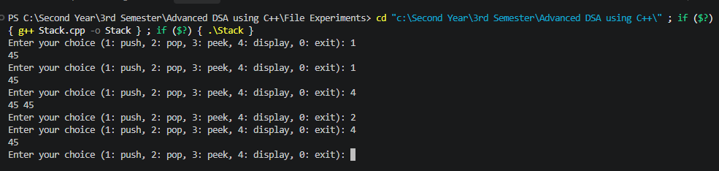

Infix to Postfix
#include <bits/stdc++.h>
using namespace std;

char st[100];
int m = 100;
int i = 0;

void push(char x) {
st[i] = x;
i++;
}

void pop() {
i--;
st[i] = -1;
}

void top() {
if (i>0) {
i--;
cout << st[i] << " ";
}
}

void display () {
for (int j=m-1; j>=0; j--) {
if (st[j] != -1) {
cout << st[j] << " ";
}
}
}

int main () {
string infix;
cout << "Enter infix expression (don't use spaces): ";
cin >> infix;
int n = infix.length();
string postfix = "";

for (int j=0; j<n; j++) {
if (isalpha(infix[j])){
postfix += infix[j];
}
else if (infix[j] == ')') {
while (i > 0 && st[i-1] != '(') {
postfix += st[i-1];
i--;
}
if (i > 0) {
i--;
}
}
else if (infix[j] == '+' || infix[j] == '-' || infix[j] == '*' || infix[j] == '/' || infix[j] == '^' || infix[j] == '%') {
push(infix[j]);
}
}
while( i > 0) {
postfix += st[i-1];
i--;
}
cout << "Postfix Conversion: " << postfix << endl;
}
Output:
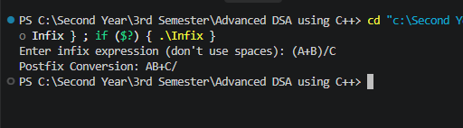

EXPERIMENT 2

Objective: To implement linear and circular queue operations using FIFO, handle overflow and underflow conditions, and display the final queue state.

Linear queue
#include <bits/stdc++.h>
using namespace std;

int q[100];
int i = 0;
int j = 0;
int n = 100;

void pop() {
if (i == j) {
cout << "Queue underflow" << endl;
return;
}
i++;
}

void push(int x) {
if (j == n) {
cout << "Queue overflow" << endl;
return;
}
q[j] = x;
j++;
}

void peek() {
if (i == j) {
cout << "Queue is empty" << endl;
return;
}
cout << q[i] << endl;
}

void display() {
if (i == j) {
cout << "Queue is empty" << endl;
return;
}
for (int k = i; k < j; k++) {
cout << q[k] << " ";
}
cout << endl;
}

int main() {
for (int k = 0; k < 100; k++) {
q[k] = -1;
}

int choice;
cout << "Enter your choice (1: enqueue, 2: dequeue, 3: peek, 4: display, 0: exit): ";
cin >> choice;

while (choice != 0) {
switch (choice) {
case 1: {
int x;
cout << "Enter element: ";
cin >> x;
push(x);
break;
}

case 2:
pop();
break;

case 3:
cout << "Front element: ";
peek();
break;

case 4:
cout << "Queue: ";
display();
break;

default:
cout << "Invalid choice" << endl;
}
cout << "Enter your choice (1: enqueue, 2: dequeue, 3: peek, 4: display, 0: exit): ";
cin >> choice;
}
return 0;
}

Output:
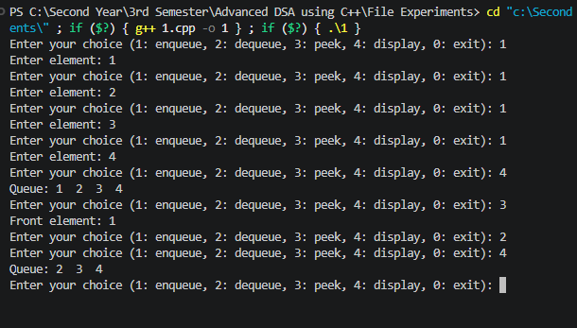

Circular queue
#include <bits/stdc++.h>
using namespace std;

int q[100];
int i = 0;
int j = 0;
int n = 100;
int cnt = 0;

void push(int x) {
if (cnt == n) {
cout << "Queue overflow" << endl;
return;
}
q[j] = x;
j = (j + 1) % n;
cnt++;
}

void pop() {
if (cnt == 0) {
cout << "Queue underflow" << endl;
return;
}
q[i] = -1;
i = (i + 1) % n;
cnt--;
}

void peek() {
if (cnt == 0) {
cout << "Queue is empty" << endl;
return;
}
cout << q[i] << endl;
}

void display() {
if (cnt == 0) {
cout << "Queue is empty" << endl;
return;
}

int k = i;
for (int x = 0; x < cnt; x++) {
cout << q[k] << " ";
k = (k + 1) % n;
}
cout << endl;
}

int main() {
for (int k = 0; k < 100; k++) {
q[k] = -1;
}

int choice;
cout << "Enter your choice (1: enqueue, 2: dequeue, 3: peek, 4: display, 0: exit): ";
cin >> choice;

while (choice != 0) {
switch (choice) {
case 1: {
int x;
cout << "Enter element: ";
cin >> x;
push(x);
break;
}

case 2:
pop();
break;

case 3:
cout << "Front element: ";
peek();
break;

case 4:
cout << "Queue: ";
display();
break;

default:
cout << "Invalid choice" << endl;
}
cout << "Enter your choice (1: enqueue, 2: dequeue, 3: peek, 4: display, 0: exit): ";
cin >> choice;
}
return 0;
}

Output:
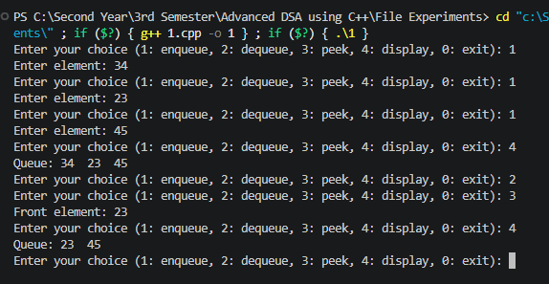

EXPERIMENT 3
Objective: To implement recursive functions to calculate the factorial and Nth Fibonacci number without using iterative constructs.
Factorial
#include <bits/stdc++.h>
using namespace std;

int factorial (int n) {
if (n == 0) {
return 1;
}
else {
return n*factorial(n-1);
}
}

int main() {
int n;
cout << "Enter a number: ";
cin >> n;

int a = factorial(n);
cout << "Factorial of " << n << " is: " << a << endl;
return 0;
}

Output:
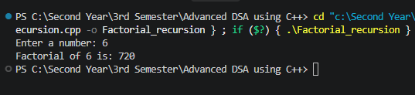

Fibonacci
#include <iostream>
using namespace std;

int fibonacci(int n, int a = 0, int b = 1) {
if (n == 0) {
return a;
}
if(n == 1) {
return b;
}
return fibonacci(n - 1, b, a + b);
}

int main() {
int n;
cout << "Enter a number: ";
cin >> n;

cout << "Nth term of fibonacci series: " << fibonacci(n) << endl;

return 0;
}
Output:
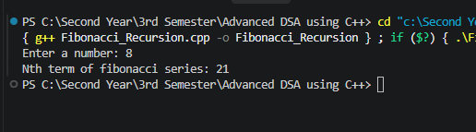

EXPERIMENT 4

Objective: To sort an array of N integers using a Divide and Conquer sorting technique such as Merge Sort or Quick Sort, and display the elements of the array in ascending order.

Merge Sort
#include <bits/stdc++.h>
using namespace std;

void merge(int arr1[], int arr2[], int size1, int size2, int arr[]) {
int i = 0, j = 0, k = 0;

while (i < size1 && j < size2) {
if (arr1[i] < arr2[j]) {
arr[k] = arr1[i];
i++;
}
else {
arr[k] = arr2[j];
j++;
}
k++;
}

while (i < size1) {
arr[k] = arr1[i];
i++;
k++;
}

while (j < size2) {
arr[k] = arr2[j];
j++;
k++;
}
}

void mergeSort(int arr[], int n) {
if (n <= 1)
return;

int size1 = n / 2;
int size2 = n - size1;

int arr1[size1];
int arr2[size2];

for (int i = 0; i < size1; i++)
arr1[i] = arr[i];

for (int i = 0; i < size2; i++)
arr2[i] = arr[size1 + i];

mergeSort(arr1, size1);
mergeSort(arr2, size2);

merge(arr1, arr2, size1, size2, arr);
}

int main() {
int n;
cout << "Enter the number of elements: ";
cin >> n;

int arr[n];
cout << "Enter the elements: ";
for (int i = 0; i < n; i++)
cin >> arr[i];

mergeSort(arr, n);
cout << "Sorted array: ";
for (int i = 0; i < n; i++)
cout << arr[i] << " ";

return 0;
}

Output:
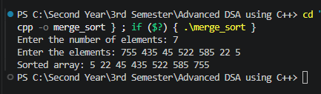

Quick Sort
#include <iostream>
using namespace std;

int partition(int arr[], int l, int h) {
int pivot = arr[h];
int i = l - 1;

for (int j = l; j < h; j++) {
if (arr[j] < pivot) {
i++;

int temp = arr[i];
arr[i] = arr[j];
arr[j] = temp;
}
}

int temp = arr[i + 1];
arr[i + 1] = arr[h];
arr[h] = temp;

return i + 1;
}

void quickSort(int arr[], int l, int h) {
if (l < h) {
int p = partition(arr, l, h);

quickSort(arr, l, p - 1);
quickSort(arr, p + 1, h);
}
}

int main() {
int n;
cout << "Enter the number of elements: ";
cin >> n;

int arr[n];
cout << "Enter the elements: ";
for (int i = 0; i < n; i++)
cin >> arr[i];

quickSort(arr, 0, n - 1);
cout << "Sorted array: ";
for (int i = 0; i < n; i++)
cout << arr[i] << " ";

return 0;
}

Output:
